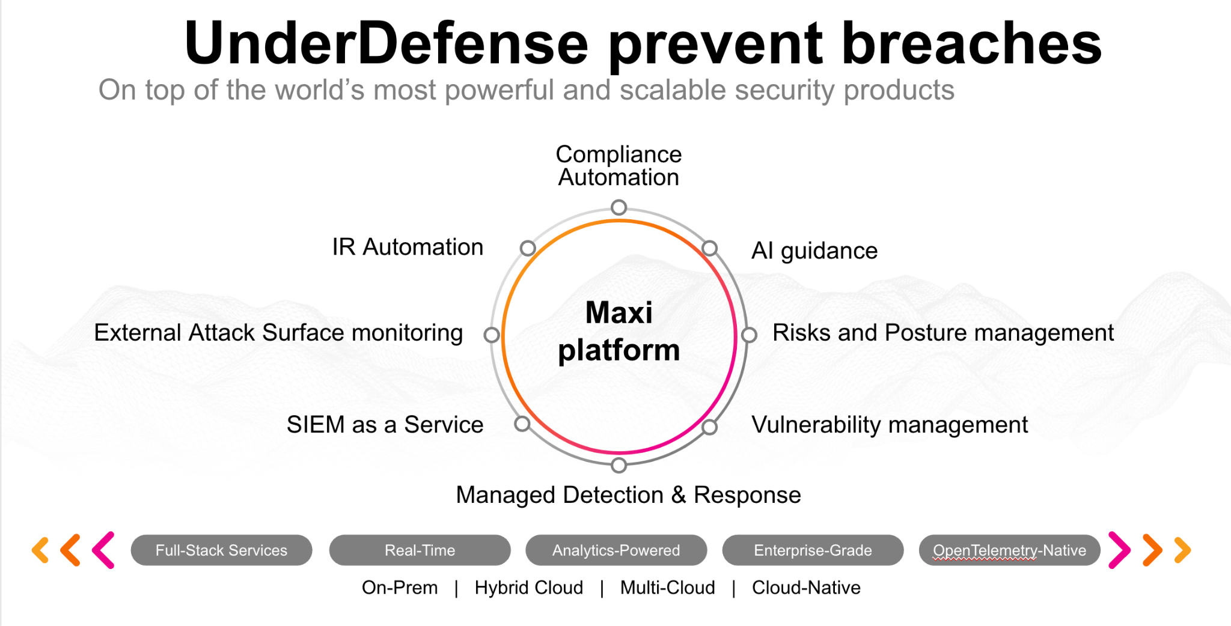**UnderDefense policy template kit**

Starting your compliance journey? UnderDefense policy template offers a comprehensive and compliance-ready document, complete with placeholders for company-specific details.

**How to use this document**

1. Thoroughly review the content of each policy, analyzing it section by section.
2. Evaluate whether the subsequent section and its associated risks are applicable to you. If it does not, remove it and/or replace it with your organization’s corresponding practices.
3. Replace any highlighted text in angled brackets < >[1] with appropriate information (Use Find to make sure that all text in angled brackets is replaced)
4. Remove this instructions page
5. Add any company-specific letterhead, branding, and formatting
6. Save this document as PDF and upload to UnderDefenseMAXI to

<https://app.underdefense.com/compliance/ISO27001/approved-policies>

# 

# **The Path to Compliance**

# We'll guide you through, ensuring a smooth path to compliance:

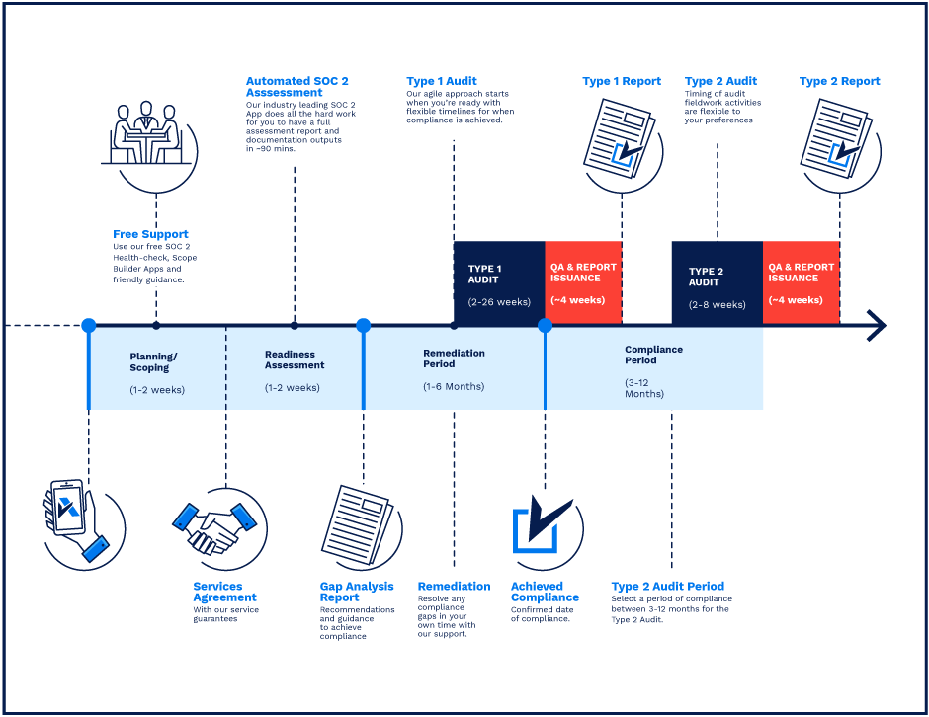

**SOC 2 Certification Timeline for SMBs with 50-250 Employees**

# 

# **Need Expert Assistance?**

| Navigating the complexities of compliance can be challenging, especially for businesses with limited internal resources or expertise.   * Experience team at the right time * Preparation of all compliance docs * Expert guidance on all tech-related issues   [**Book a call with expert**](https://meetings.hubspot.com/underdefense/help-with-compliance) | **Take your compliance from probable to guaranteed.** |
| --- | --- |

**<Your Company Logo>**

**Asset Management Policy**

# ***Version Control Table***

| Version | Date | Author | Description |
| --- | --- | --- | --- |
| 1.0 | <Date> | <Author> | Issued |
| 1.0 | <Date> | <Author> | Reviewed |
| 1.0 | <Date> | <Author> | Approved |
| **1.0** | <Date> | <Author> | **Granted “FINAL” status** |

| **Date of Next Revision** | **<date>** |
| --- | --- |

This policy will be reviewed for continued completeness, relevance, and accuracy within 1 year of being granted “final” status and at yearly intervals after that.

The version control table will show the published update date and provide a thumbnail of the significant change. CAUTION: the thumbnail is not intended to summarize the difference and is not a substitute for reading the full text.

# ***Table of Contents***

**The Path to Compliance 2**

**We'll guide you through, ensuring a smooth path to compliance: 2**

**Need Expert Assistance? 2**

**Version Control Table 4**

**Table of Contents 5**

**Purpose 6**

**Scope 6**

**Policy 6**

Asset Types 6

Asset Tracking Requirements 6

Asset Fixing 7

Acquiring/Termination of corporate assets 7

Acquiring process 7

Termination process 7

Asset Return 8

Asset Disposal and Reuse 8

**Disciplinary actions 8**

**Change, Review, and Update 8**

**Responsibility 8**

**Reference 8**

**Related Documents 8**

**Procedures & Implementation best practices 9**

# 

# 

# Purpose

The purpose is to create effective asset management essential to the continuity, development, and growth of <Company>, to confirm that capital expenditure by the <Company> is planned, evaluated, authorized, implemented, monitored, and reported systematically to meet the objective of best practice.

# Scope

This policy applies to all employees, contractors, subcontractors, consultants, temporaries, guests, and any third party that uses <Company> information assets or information resources and services.

# Policy

* All critical assets used for <Company> are reviewed annually in the <Company> Critical Asset Registry.

## Asset Types

* Devices assigned to employees:
  + HHD
  + SSD
  + Laptop
  + Monitor
* Office devices:
  + Network Adapter
  + Network Attached Storage
  + Powerline adapter
  + Printer
  + Router
  + Firewall
  + Single Board Computer
  + Server
  + Speaker
  + Switch
  + TV
  + Headphones

## Asset Tracking Requirements

The current state of corporate assets is tracked in <HR managing tool>.The assets are assigned directly to the employee. The description of the asset varies according to the value of the asset and its usage history.

* Asset name
* Asset ID
* Asset type (labeling)
* Model
* Assignee
* More detailed characteristics (RAM, SSD, processor) - for laptops only
* Purchasing cost

## Asset Fixing

In case of any device (laptop, printer, smartphone, etc.) malfunctions immediately report to both your Asset Manager and/or Office Manager (if applicable) and your Direct Manager. The Asset Manager will investigate and determine the appropriate action to rectify the issue. While the Direct Manager will ensure minimal disruption to work. Prompt reporting of issues will minimize potential productivity impact.

The Asset Manager is accountable for fixing assets in the company. It can be performed at the employee’s request or during regular asset reviews. When the broken asset is found, the Asset Manager approves this matter with the COO and brings it to the service center for repair.

## Acquiring/Termination of corporate assets

### Acquiring process

* The Head of HR or PM creates an issue in the HR system indicating that new hires require a laptop and assigns this request to the COO. The COO determines the necessary characteristics for the laptop, such as SSD, preferred operating system, and RAM, based on the new employee's role.
* Asset Manager prepares the laptop for a new hire:
  + Performs formatting for a chosen laptop (if not done before).
  + Checks the general state and enables full disk encryption.
  + Installs the security package (<List of programs>).
  + Assigns this appliance to the new hire in the <HR managing tool>.
* Depending on the location of the employee requesting the asset, the shipment is directed to the office or directly to the employee’s workplace.
* Asset Manager confirms that the new employee has changed username to [First_Name Last_Name] and the unique passwords for the disk encryption and screen lock.

### Termination process

* The Head of HR or PM creates an issue in the ticket system, assigns this request to the Asset Manager, and marks the last working day.
* The employee brings the laptop and any other appliance to the office on the last working day and checks it with the Asset Manager.
* The Asset Manager claims that the laptop and other assets are returned and confirms that in the Asset Management Board.
* Asset Manager performs formatting for the returned laptop.

## Asset Return

All employees are financially accountable for assigned assets. In case of unacceptable use of assets or other disciplinary violations, the employee must take responsibility for compensation.

## Asset Disposal and Reuse

When disposing of any asset, sensitive data must be removed before disposal. The Asset Manager will determine what type of data destruction protocol should be used for the appropriate erasure.

# Disciplinary actions

Employees who violate this policy may face disciplinary consequences in proportion to their violation. Management will determine how severe an employee’s offense is and take the appropriate action.

# Change, Review, and Update

This policy shall be reviewed once every year unless the owner considers an earlier review necessary to ensure that the policy remains current. Changes to this policy shall be exclusively performed by the ISMS Manager and approved by the ISMS Committee.

# Responsibility

This is the responsibility of the ISMS Manager to maintain and make sure everyone is aware of this policy.

# Reference

* ISO 27001 Annex A.8.1.1 Inventory of Assets
* ISO 27001 Annex A.8.1.2 Ownership of Assets
* ISO 27001 Annex A.8.1.3 Acceptable Use of Assets
* ISO 27001 Annex A.8.1.4 Return of Assets

# Related Documents

* <Company> Critical Asset Registry

1. All fields in this document marked by angled brackets < > and highlighted must be filled in.